1-Modulator

🎛️ What is a Modulator?
# Source: AI Source: Provided by: [Data Path: Persons Table -> ID Column: 1, Name_En Column: Motasem Essam] -> From: [ChatGPT] on [1/23/2026]
A modulator is an electronic device or circuit that performs modulation — meaning it takes a carrier wave and adds information (like voice, music, or data) to it, so it can be transmitted over a distance via radio waves, cables, or light.
In simple terms:
A modulator is what “loads the message onto the wave” for transmission.

⚙️ What Does a Modulator Do?
# Source: AI Source: Provided by: [Data Path: Persons Table -> ID Column: 1, Name_En Column: Motasem Essam] -> From: [ChatGPT] on [1/23/2026]
- Takes input data (e.g. voice, video, internet packets).
- Takes a carrier wave (pure signal from an oscillator).
- Modifies the carrier based on the input data (modulation).
- Sends the modulated signal to the transmitter or antenna.

🧩 Types of Modulators (Based on Modulation Type):
# Source: AI Source: Provided by: [Data Path: Persons Table -> ID Column: 1, Name_En Column: Motasem Essam] -> From: [ChatGPT] on [1/23/2026]
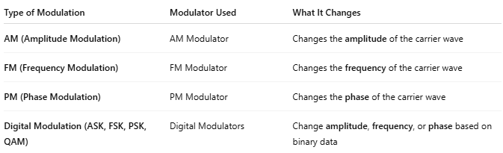

Type of Modulation | Modulator Used | What It Changes
AM (Amplitude Modulation) | AM Modulator | Changes the amplitude of the carrier wave
FM (Frequency Modulation) | FM Modulator | Changes the frequency of the carrier wave
PM (Phase Modulation) | PM Modulator | Changes the phase of the carrier wave
Digital Modulation (ASK, FSK, PSK, QAM) | Digital Modulators | Change amplitude, frequency, or phase based on binary data

🧠 Where Modulators Are Used:
# Source: AI Source: Provided by: [Data Path: Persons Table -> ID Column: 1, Name_En Column: Motasem Essam] -> From: [ChatGPT] on [1/23/2026]
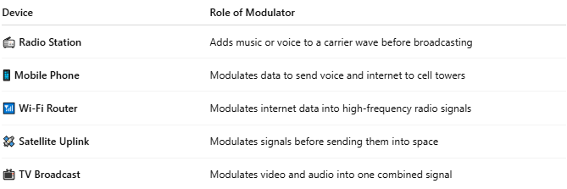

Device | Role of Modulator
📻 Radio Station | Adds music or voice to a carrier wave before broadcasting
📱 Mobile Phone | Modulates data to send voice and internet to cell towers
📶 Wi-Fi Router | Modulates internet data into high-frequency radio signals
🛰️ Satellite Uplink | Modulates signals before sending them into space
📺 TV Broadcast | Modulates video and audio into one combined signal

📖 Summary:
# Source: AI Source: Provided by: [Data Path: Persons Table -> ID Column: 1, Name_En Column: Motasem Essam] -> From: [ChatGPT] on [1/23/2026]
A modulator is the electronic brain behind wireless communication. It adds real data (like voice or video) to a carrier wave so it can be sent through the air or a cable. Without it, you’d just be sending empty waves!

2-Carrier Wave

📡 What Is a Carrier Wave?
# Source: AI Source: Provided by: [Data Path: Persons Table -> ID Column: 1, Name_En Column: Motasem Essam] -> From: [ChatGPT] on [1/23/2026]
A carrier wave is a steady, high-frequency electromagnetic wave that is used to carry information — such as voice, video, or data — from one place to another by modulation.
On its own, a carrier wave is just an empty signal. When modulated, it becomes a vehicle for transmitting useful information over the air or cables.

A carrier wave is:
- A pure sine wave with a constant frequency and amplitude.
- Created by an oscillator in a transmitter.
- "Empty" on its own — it doesn’t contain meaningful data until it’s modulated.
Think of it like a blank truck that can carry different types of cargo (voice, video, internet data) when loaded.

🎚️ Key Characteristics of a Carrier Wave:
# Source: AI Source: Provided by: [Data Path: Persons Table -> ID Column: 1, Name_En Column: Motasem Essam] -> From: [ChatGPT] on [1/23/2026]
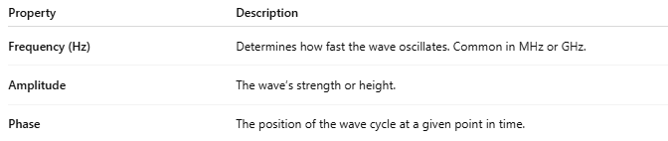

Property | Description
Frequency (Hz) | Determines how fast the wave oscillates. Common in MHz or GHz.
Amplitude | The wave’s strength or height.
Phase | The position of the wave cycle at a given point in time.

⚙️ How a Carrier Wave Works:
# Source: AI Source: Provided by: [Data Path: Persons Table -> ID Column: 1, Name_En Column: Motasem Essam] -> From: [ChatGPT] on [1/23/2026]
- A signal generator or oscillator produces the carrier wave.
- A modulator adds information (data, voice, etc.) to the carrier wave.
- The modulated wave is transmitted via an antenna or cable.
- The receiver gets the wave and uses a demodulator to extract the original information.

🔁 Types of Modulation on a Carrier Wave:
# Source: AI Source: Provided by: [Data Path: Persons Table -> ID Column: 1, Name_En Column: Motasem Essam] -> From: [ChatGPT] on [1/23/2026]
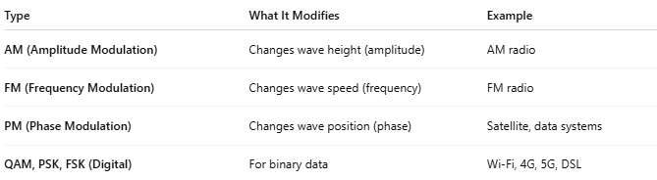

Type | What It Modifies | Example
AM (Amplitude Modulation) | Changes wave height (amplitude) | AM radio
FM (Frequency Modulation) | Changes wave speed (frequency) | FM radio
PM (Phase Modulation) | Changes wave position (phase) | Satellite, data systems
QAM, PSK, FSK (Digital) | For binary data | Wi-Fi, 4G, 5G, DSL

🧠 Why Use Carrier Waves?
# Source: AI Source: Provided by: [Data Path: Persons Table -> ID Column: 1, Name_En Column: Motasem Essam] -> From: [ChatGPT] on [1/23/2026]
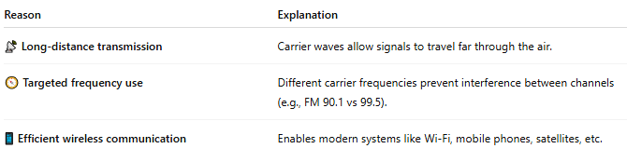

Reason | Explanation
📡 Long-distance transmission | Carrier waves allow signals to travel far through the air.
🧭 Targeted frequency use | Different carrier frequencies prevent interference between channels (e.g., FM 90.1 vs 99.5).
📱 Efficient wireless communication | Enables modern systems like Wi-Fi, mobile phones, satellites, etc.

📻 Example in Real Life:
# Source: AI Source: Provided by: [Data Path: Persons Table -> ID Column: 1, Name_En Column: Motasem Essam] -> From: [ChatGPT] on [1/23/2026]
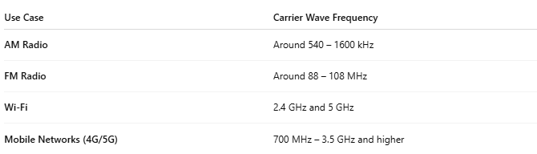

Use Case | Carrier Wave Frequency
AM Radio | Around 540 – 1600 kHz
FM Radio | Around 88 – 108 MHz
Wi-Fi | 2.4 GHz and 5 GHz
Mobile Networks (4G/5G) | 700 MHz – 3.5 GHz and higher

📖 Summary:
# Source: AI Source: Provided by: [Data Path: Persons Table -> ID Column: 1, Name_En Column: Motasem Essam] -> From: [ChatGPT] on [1/23/2026]
A carrier wave is a blank signal that carries useful information when it is modulated. It is essential in all wireless systems — radio, TV, mobile networks, Wi-Fi, satellites, and more.

3-Modulation

🎚️ What is Modulation?
# Source: AI Source: Provided by: [Data Path: Persons Table -> ID Column: 1, Name_En Column: Motasem Essam] -> From: [ChatGPT] on [1/23/2026]
Modulation is the process of adding information (like voice, music, or data) to a carrier wave so it can be transmitted over a distance via radio, cable, or other media.
Without modulation, a carrier wave is just a plain signal with no information. Modulation makes that wave "carry" the data to the receiver.

🧠 Why Modulation Is Needed:
# Source: AI Source: Provided by: [Data Path: Persons Table -> ID Column: 1, Name_En Column: Motasem Essam] -> From: [ChatGPT] on [1/23/2026]
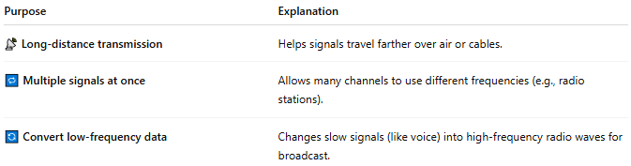

Purpose | Explanation
📡 Long-distance transmission | Helps signals travel farther over air or cables.
🔁 Multiple signals at once | Allows many channels to use different frequencies (e.g., radio stations).
🔄 Convert low-frequency data | Changes slow signals (like voice) into high-frequency radio waves for broadcast.

⚙️ Types of Modulation:

1. Analog Modulation
# Source: AI Source: Provided by: [Data Path: Persons Table -> ID Column: 1, Name_En Column: Motasem Essam] -> From: [ChatGPT] on [1/23/2026]
Used for continuous signals like voice and music.
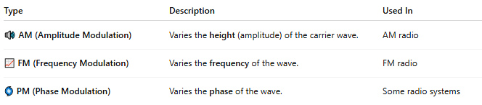
Type | Description | Used In
🔊 AM (Amplitude Modulation) | Varies the height (amplitude) of the carrier wave. | AM radio
📈 FM (Frequency Modulation) | Varies the frequency of the wave. | FM radio
🌀 PM (Phase Modulation) | Varies the phase of the wave. | Some radio systems

2. Digital Modulation
# Source: AI Source: Provided by: [Data Path: Persons Table -> ID Column: 1, Name_En Column: Motasem Essam] -> From: [ChatGPT] on [1/23/2026]
Used for transmitting binary data (1s and 0s).
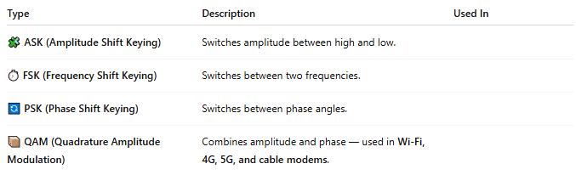

Type | Description | Used In
🧩 ASK (Amplitude Shift Keying) | Switches amplitude between high and low.
⏱️ FSK (Frequency Shift Keying) | Switches between two frequencies.
🔄 PSK (Phase Shift Keying) | Switches between phase angles.
📦 QAM (Quadrature Amplitude Modulation) | Combines amplitude and phase — used in Wi-Fi, 4G, 5G, and cable modems.

📡 How Modulation Works (Simplified):
# Source: AI Source: Provided by: [Data Path: Persons Table -> ID Column: 1, Name_En Column: Motasem Essam] -> From: [ChatGPT] on [1/23/2026]
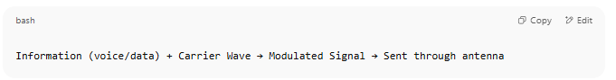
Information (voice/data) + Carrier Wave → Modulated Signal → Sent through antenna

At the receiver end:
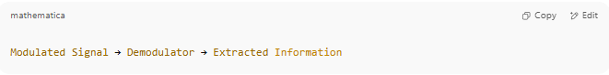
Modulated Signal → Demodulator → Extracted Information

📖 Summary:
# Source: AI Source: Provided by: [Data Path: Persons Table -> ID Column: 1, Name_En Column: Motasem Essam] -> From: [ChatGPT] on [1/23/2026]
Modulation is how we encode data onto a carrier wave so it can be transmitted through air, cable, or space. It's the core of all wireless and wired communication systems, from radios to smartphones to satellites.

